**Assignment 1**

**TITLE:** Implement DFS and BFS Algorithm. Use and Undirected Graph and develop a Recursive Algorithm for searching all the vertices of the graph or tree data structure.

**AIM:** Aim of this practical is to develop DFS and BFS algorithm programs in programming language.

**OBJECTIVES:** Based on above main aim following are the objectives

1. To study BFS
2. To study DFS
3. To apply algorithmic logic in implementation of program.

# Breadth-first Search:

* + Breadth-first search is the most common search strategy for traversing a tree or graph. This algorithm searches breadthwise in a tree or graph, so it is called breadth-first search.
  + BFS algorithm starts searching from the root node of the tree and expands all successor node at the current level before moving to nodes of next level.
  + The breadth-first search algorithm is an example of a general-graph search algorithm.
  + Breadth-first search implemented using FIFO queue data structure.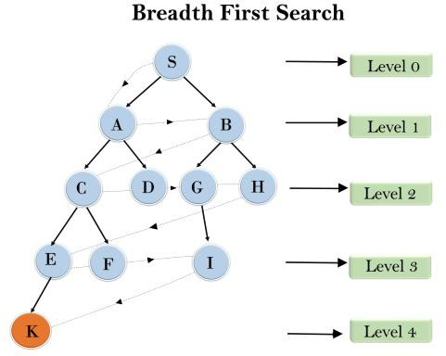

In the above tree structure, we have shown the traversing of the tree using BFS algorithm from the root node S to goal node K. BFS search algorithm traverse in layers, so it will follow the path which is shown by the dotted arrow, and the traversed path will be:

S---> A--->B---->C--->D---->G--->H--->E---->F---->I >K

* **Time Complexity:** Time Complexity of BFS algorithm can be obtained by the number of nodes traversed in BFS until the shallowest Node. Where the d= depth of shallowest solution and b is a node at every state.

## T (b) = 1+b2+b3+. + bd= O (bd)

* **Space Complexity:** Space complexity of BFS algorithm is given by the Memory size of frontier which is O(bd).
* **Completeness:** BFS is complete, which means if the shallowest goal node is at some finite depth, then BFS will find a solution.
* **Optimality:** BFS is optimal if path cost is a non-decreasing function of the depth of the node.

## Algorithm:

* 1. Pick any node, visit the adjacent unvisited vertex, mark it as visited, display it, and insert it in a queue.
  2. If there are no remaining adjacent vertices left, remove the first vertex from the queue.
  3. Repeat step 1 and step 2 until the queue is empty or the desired node is found.

## Program:

graph = {

'A' : ['B','C'],

'B' : ['D', 'E'],

'C' : ['F'],

'D' : [],

'E' : ['F'], 'F' : []

}

visited = [] # List to keep track of visited nodes. queue = [] #Initialize a queue

def bfs(visited, graph, node): visited.append(node) queue.append(node)

while queue:

s = queue.pop(0) print (s, end = " ")

for neighbour in graph[s]: if neighbour not in visited:

**Output:**

Following is the Path using Breadth-First Search A B C D E F

visited.append(neighbour) queue.append(neighbour)

# Driver Code

print("Following is the Path using Breadth-First Search") bfs(visited, graph, 'A')

**Conclusion**: Thus we have studied BFS & DFS algorithm in detail and implemented using recursive function.